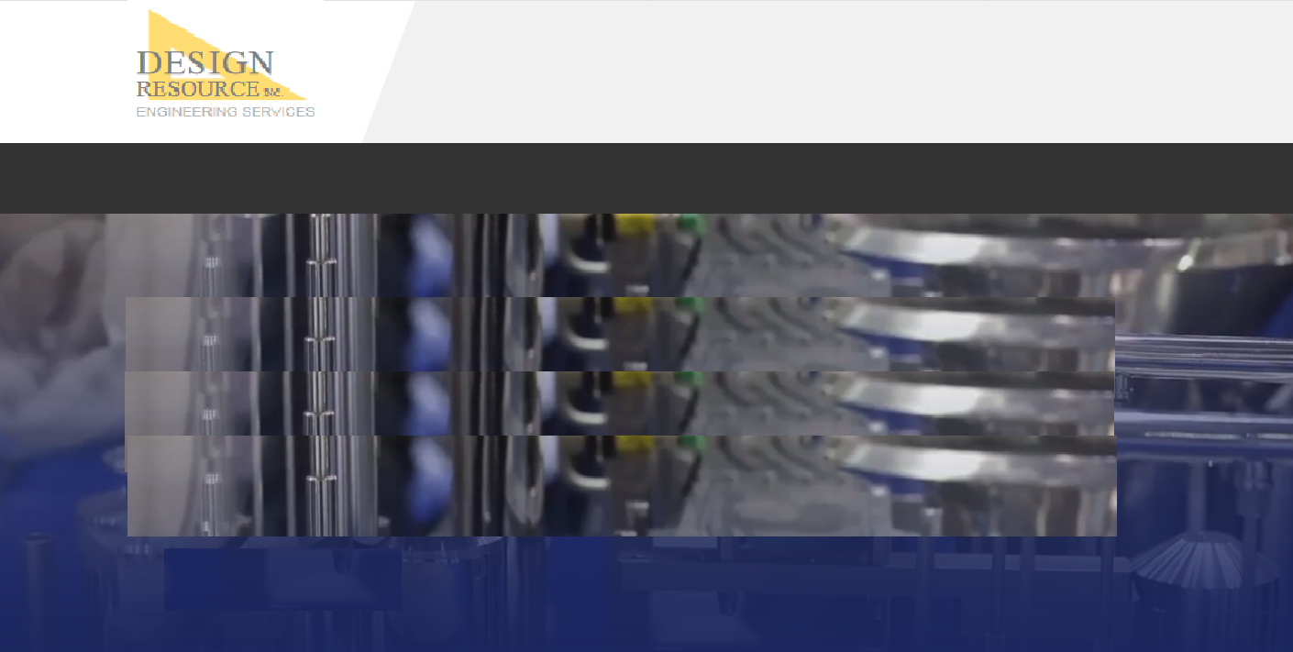

**Core Staffing**

* Our core engineering staff is available for short or long term assignment.
* Rely on the same individuals to return when you require, reducing ramp up time.

***Our professionals on site at your facility to ensure the job’s done right.***

**HOME | ENGINEERING | STAFFING | COMPANY | CONTACT**

**© 2019 DESIGN RESOURCE, INC.**

**Core Staffing**

**HOME ENGINEERING STAFFING COMPANY CONTACT**